Update the max speed (max_vel_x in teb planner)

The initial setting of max_vel_x in teb_local_planner_params_carlike.yaml is 2.0 (i.e. 2 m/s). For me, that is too fast for initial testing. To reduce that I followed these instructions.

* Ctrl-Atl-t
* Start the Docker container
* # cd /root/tractor_ws/src/lawn_tractor/lawn_tractor_navigation/config
* # vim teb_local_planner_params_carlike.yaml
* Find the statement below

# Robot

max_vel_x: 2.0 {replace with your new value for example .75, 1.0, 1.5}

* + Insert - to insert characters
  + :w{enter} - to write the edits
  + :q{enter} - to quit the editor
* # cd /root/tractor_ws
* # catkin build && source devel/setup.bash
* Save the Docker image, $ docker ps # to gather container name

| al@al-ThinkPad-W530:~$ docker commit -m "update max speed" busy_gould rosagriculture/lawn_tractor  sha256:f9445f311513b1fce067777c12c125efefcbab33a36d38d3b45cbe4e79228d34  al@al-ThinkPad-W530:~$ |
| --- |

* $ docker commit -m ‘update speed’ busy_gould rosagriculture/lawn_tractor

To get a local version:

$git pull origin branch_name

* $ git clone https://github.com/ros-agriculture/ros_lawn_tractor.git

<https://github.com/ros-agriculture/lawn_tractor.git>

git pull {repo} {remotebranchname}:{localbranchname}

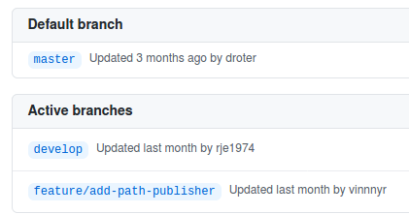

Problem statement: How to start the develop branch on the physical laptop.

Try it now; Maybe it works.